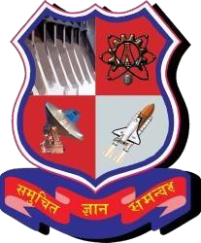**GUJARAT TECHNOLOGICAL UNIVERSITY** 

Chandkheda, Ahmedabad

Affiliated

SAL INSTITUTE OF TECHNOLOGY AND ENGINEERING RESEARCH

A

Project Report

On

## EDUCATION

Under the course of

**DESIGN ENGINEERING II–B (3160001)**

B. E. Semester – VI

***Submitted by:***

|  |  |
| --- | --- |
| **Sr.** | **Name of student ENROLLMENT NO.** |
| 01. | PAREKH NIKHIL 190670107074 |
| 02. | PATEL YASH 190670107108 |
| 03. | PATEL YUG 190670107109 |
| 04. | SHAH VATSAL 190670107129 |

**Prof. Harsha Padheriya**

(Internal guide )

**Prof.Sudha Patel**

**(**Head of Department**)**

**Academic year**

(2021-2022)

# GUJARAT TECHNOLOGICAL UNIVERSITY

Chandkheda, Ahmedabad

Affiliated

SAL INSTITUTE OF TECHNOLOGY AND ENGINEERING RESEARCH

CERTIFICATE

|  |  |
| --- | --- |
| **Sr.** | **Name of student ENROLLMENT NO.** |
| 01. | PAREKH NIKHIL 190670107074 |
| 02. | PATEL YASH 190670107108 |
| 03. | PATEL YUG 190670107109 |
| 04. | SHAH VATSAL 190670107129 |

As fulfilment of the requirement for the award B.E. in Computer Engineering Sem. - 6 at Sal Institute of Technology Engineering & Research is the record of work that has been successfully and satisfactorily completed under supervision and guidance during the academic year 2021-22.

**Prof. Harsha Padheriya Prof. Sudha Patel**

**Internal Guide Head of Department**

ACKNOWLEDGEMENT

When we reach the completion of the project giving credit becomes a must, as without the support of the other so many peoples’ help and guidance this project could not be completed successfully.

We would like to thank **Harsha Padheriya** for guiding us and showing their views on the project for framing the realistic picture of the requirement and involved needed in this project. They were always there with their great ideas and suggestions whenever we needed. They took a great deal of interest in our work and encouraged us to outperform ourselves They believed in us and were a pillar of strength for us.

We would like to thank to help us prepare this project. We would also appreciate their guidance and technical knowledge they gave us regarding this project.

Last but not least, our heartfelt appreciation goes to all those not named here, but who have rendered their co-operation, little or more, directly or indirectly in the course of development of this Decolourisation of Dye waste water by Adsorption on Alumina Adsorbent.

Thanking All.

Your Truly :

NIKHIL PAREKH

YASH PATEL

YUG PATEL

VATSAL SHAH

**Contents** : -

1. ) Abstract
2. ) Introduction
3. ) Mind Map
4. ) AEIOU Canvas
5. ) Empathy Canvas
6. ) Ideation Canvas
7. ) Product Development Canvas
8. ) LNM Canvas
9. ) Prototype Model

**1.Abstract:**

The power of work is Education, where as the problem is lack of availability of study materials for higher education,as it is in general and more relatable to the students studying through the online classes in the pandemic period. The unavailability of study materials specially during the exams drivers the students to panicking and anxiety. So, in order to solve this problem, our team is going to make a webapplication or a website that will help the students by providing subject-help the students by providing subject-wise study material and lecture video links,for every semester,helping their revision at the last moments of their examinations. the resources that are going to be used in this project include learning of servel development languages like javascript,HTML,CSS,PHP, etc. it will also require research of study materials from different sources and platforms available on the internet.

**2.INTRODUCTION:**

In the Education domain, the lack of availability of study material poses as a major challenge, especially in the times of pandemic where everyone is locked inside their houses and E-learning becomes the only way possible of education. Thus, this EDUCATION project have been made to ensure that everyone can afford to have quality learning and they don't have to compromise with their studies.

It will cover all the requirements of students wanting to study for their respective courses, just one click away!

**3.Mind Map:**

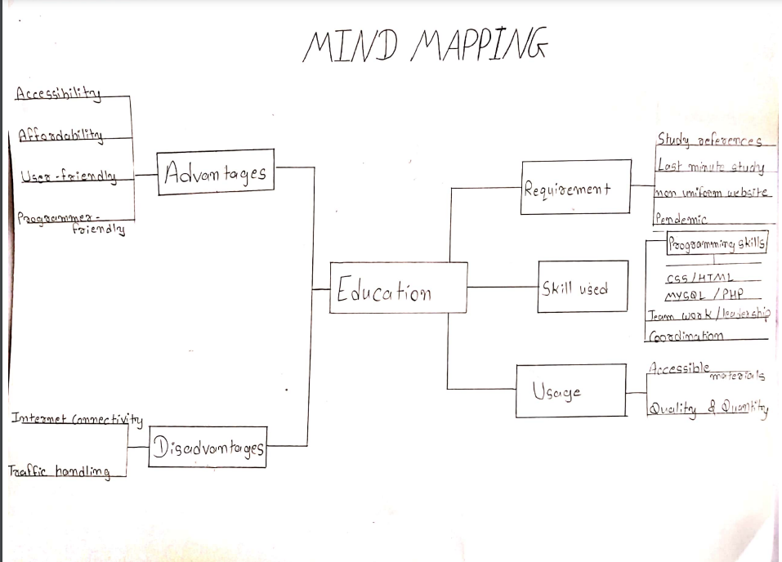

This mind map of our project depicts the various fields, questions and problems that can be solved through the study material app

For eg: the person can learn various skills and programs through the programme based courses

**4.AEIOU Canvas:**

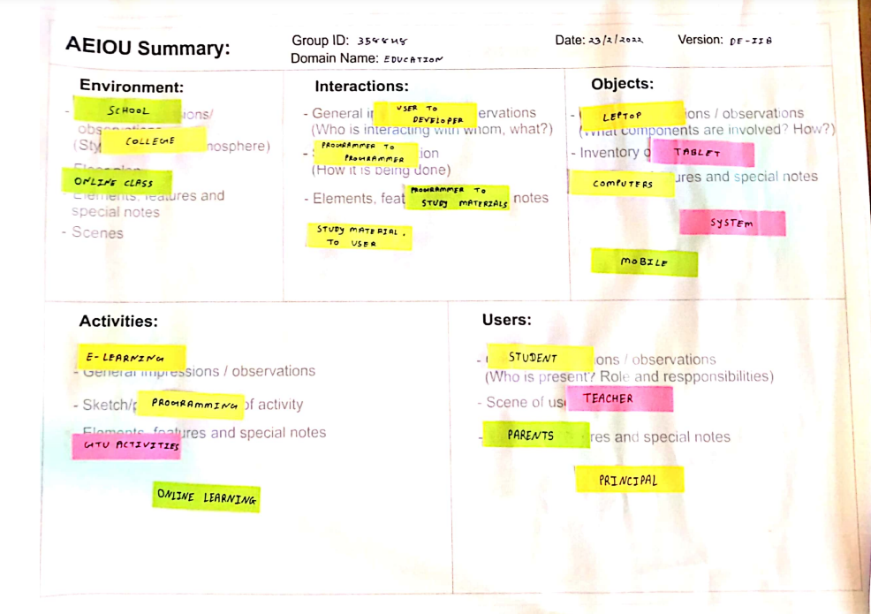

**5. Empathy Canvas:**

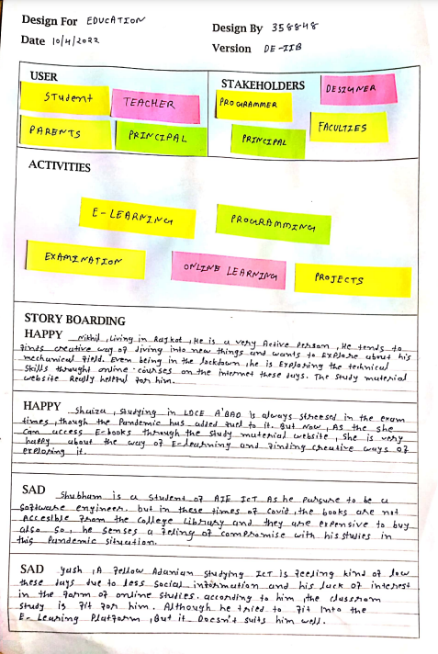

In this pandemic situation where, offline classes are closed this e- learning material can help the student to study in many ways

So, we have come up with solution to this.

**Activities: -**

|  |  |
| --- | --- |
| 1. | learning |
| 2. | examination |
| 3. | projects |
| 4. | competitions |
| 5. | E-learning books |
|  |  |

**Stories:-**

1.Happy:

Due to e-learning material Nikhil find it very easy to enhance his skills and learn in very innovative way and it make his skills very creative.

Another example is of shaiza, who is worried about exams the videos related to topics and material help her to crack the exam.

2. Sad:

Due to enhance pressure of study some students need personal guidance of faculties to teach him like Shubham and guide him which is become hurdle in his career.

Some students can’t just resist the environment of e-learning there is nothing wrong in that it is there personal interest however they try to accept it.

➢ **Conclusion:-**

To conclude, we have given so much time to all the process in this Emapthy canvas. We have done lots of testing to go. Moreover, there was a lot of difficulties we faced during all of above experiments, but the simple methodology kept us going.

**6.Ideation Canvas:**

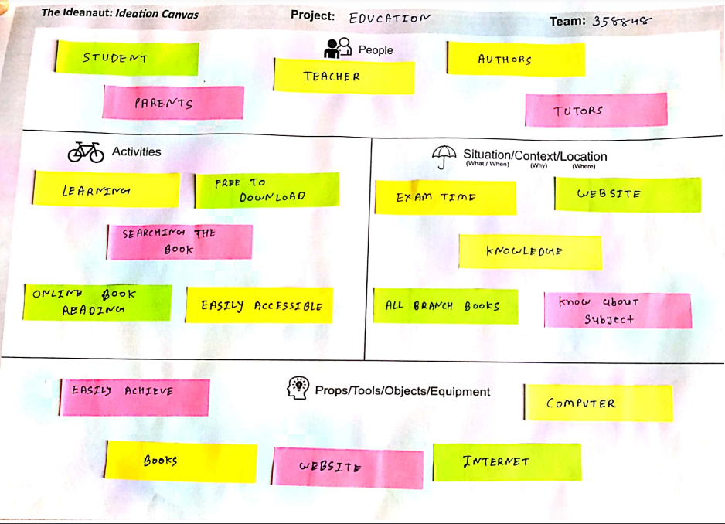

* + **Situation/Context/Location:-**

1.Exam time-during exam time the e-learning materials is very helpful for students to prepare for exam

2.Easily achieve books

3.Know about subject

4.Knowledge

5.All branch books

* + **Props/Possible solutions:**
    1. Website
    2. Books
    3. Internet
    4. Free of cost
    5. Computer

**7.Product Development Canvas:**

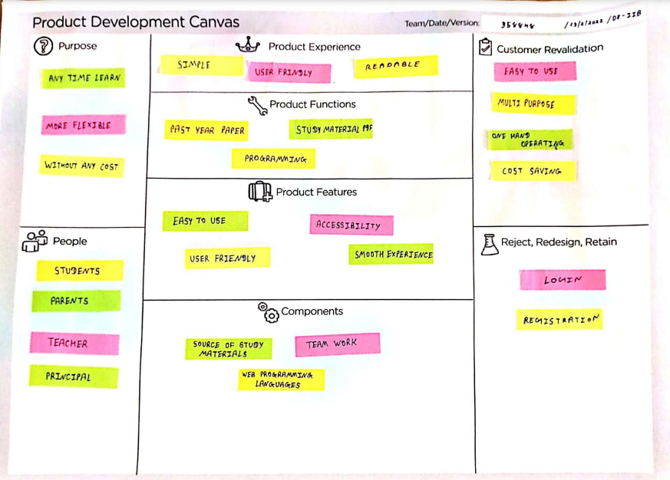

* + **PURPOSE:**

To help the needy students with some study material which can help them during their exam preparation.

* + **People:**

* 1. Teacher
  2. Principal
  3. Student
  4. Director
  5. Government
  6. Parents

**8.LNM Canvas:**

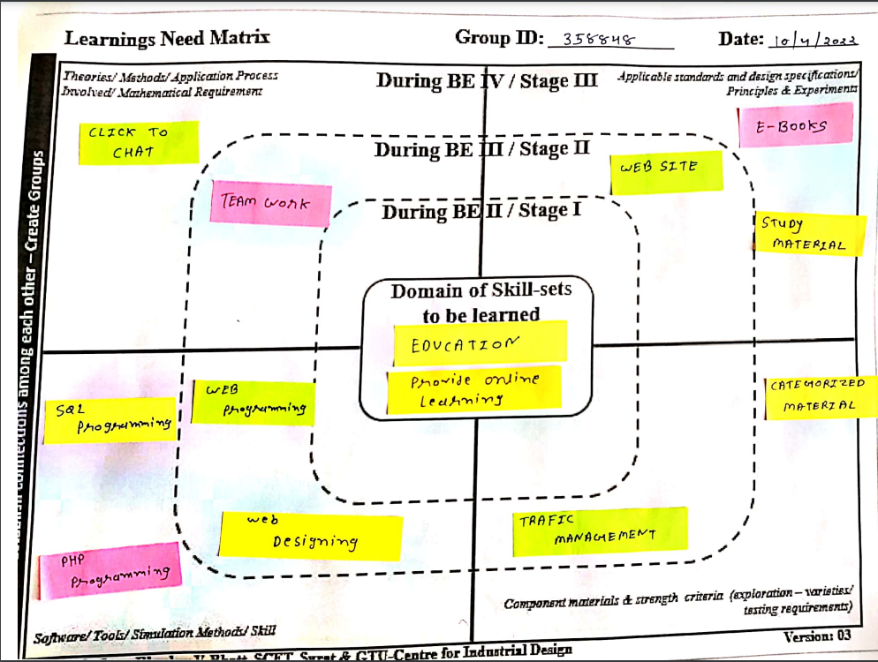

**9.Prototype Model :-**

